LAB Logbook

Lab 1
Lab 2
Lab 3
Lab 4
Lab 5
Lab 6
Lab 7
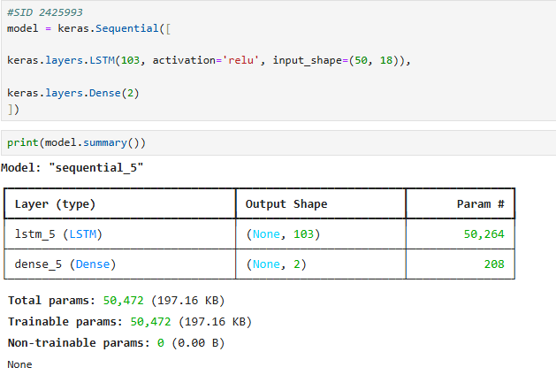
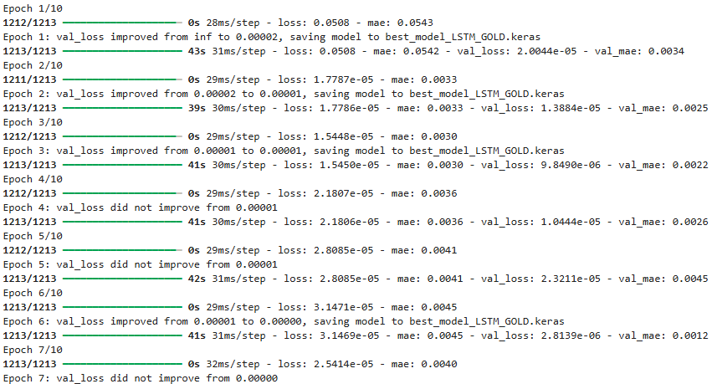
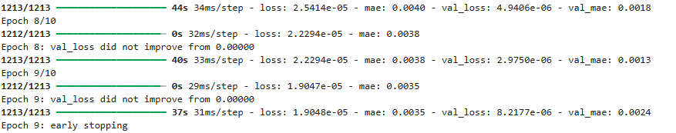
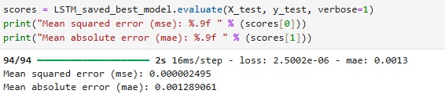
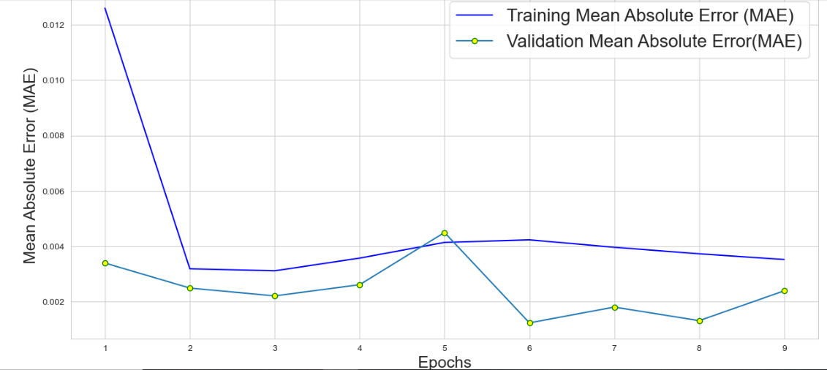
Lab 8

Lab 9

Lab 10

Lab 11

Lab 12

